**Clatsop County**

**Community Development**

**800 Exchange Street, Suite 100**

**Astoria, OR 97103**

**ph: 503-325-8611**



**fx: 503-338-3606**

**em: comdev@co.clatsop.or.us** [**www.co.clatsop.or.us**](http://www.co.clatsop.or.us)

**PUBLIC NOTICE FOR AN ISSUE BEFORE THE SOUTHWEST COASTAL**

**CITIZENS DESIGN REVIEW / ADVISORY COMMITTEE**

**AND CLATSOP COUNTY HEARINGS OFFICER**

In the matter of a Major Design Review application submitted by Edward Hodges, Curran-McLeod, Inc., on behalf of the Arch Cape Sanitary District, for 48-foot variance to the 50-foot riparian setback and a two-foot variance to the five-foot property line setback and design review for construction of an emergency power shelter building on property within the public right-of-way, located at the intersection of Pacific Road and Sally’s Alley, T4N, R10W, Sec. 31; and for repair of an existing pump at an existing sewer pump station, located on T4N, R10W, Section 19CC, TL 02401, owned by Walter and Suzanne Nupen, and also known as 80132 Pacific Road and at the intersection with Sally’s Alley.

(*For a map see Page 2 of this notice*)

APRX. DATE OF DESIGN REVIEW RECOMMENDATION: August 21, 2013

COMMENT PERIOD: August 1, 2013, to August 23, 2013

**DESIGN REVIEW MEETING: Correction August 21, 2013, 6 pm, Arch Cape Fire Hall, 79729 Highway 101, Arch Cape, Oregon**

SEND COMMENTS TO: Public Service Building 800, 800 Exchange Street, Suite 100, Astoria, Oregon 97103

CONTACT PERSON: Julia Decker, Clatsop County Planner

You are receiving this notice because you either own property within 250 feet of the property that serves as the subject of the land use application described in this letter or you are considered to be an affected state or federal agency, local government, or special district. A vicinity map for the subject property may be found on page 2.

NOTICE IS HEREBY GIVEN that Clatsop County’s Community Development Department has received the land use application described in this letter. Pursuant to section 4.100 of the Clatsop County Land Water Development and Use Ordinance, a **Public Meeting is scheduled before the Design Review Committee on Wednesday, August 21, 2013, to review and make a recommendation regarding the application, pursuant to Section 2.020 of the Clatsop County Land and Water Development and Use Ordinance (LWDUO).** Pursuant to Section 2.025 of the LWDUO, the Hearings Officer is tentatively scheduled to hear the matter, including evidence and testimony, on Friday, September 20, 2013, at the Judge Guy Boyington Building, 820 Commercial Street, Astoria, OR 97103. The Hearings Officer will make a decision at a later date. A separate notice will be issued for the hearing before the Hearings Officer.

All interested persons are invited to submit testimony and evidence in writing by addressing a letter to the Design Review Committee and / or the Clatsop County Hearings Officer, 800 Exchange Street, Suite 100, Astoria, OR 97103. Written comments may also be sent via FAX to 503-338-3606 or via email to [jdecker@co.clatsop.or.us](mailto:jdecker@co.clatsop.or.us). Written comments must be received in this office no later **than 4 p.m. on Wednesday, August 14, 2013, in order to be considered by the Design Review Committee and by 5 pm on Thursday, September 19, 2013, in order to be considered by the Hearings Officer**.

**NOTE:** Failure to raise an issue in a hearing, in person or by letter, or failure to provide statements or evidence sufficient to afford the decision maker an opportunity to respond to the issue precludes an appeal based on that issue.

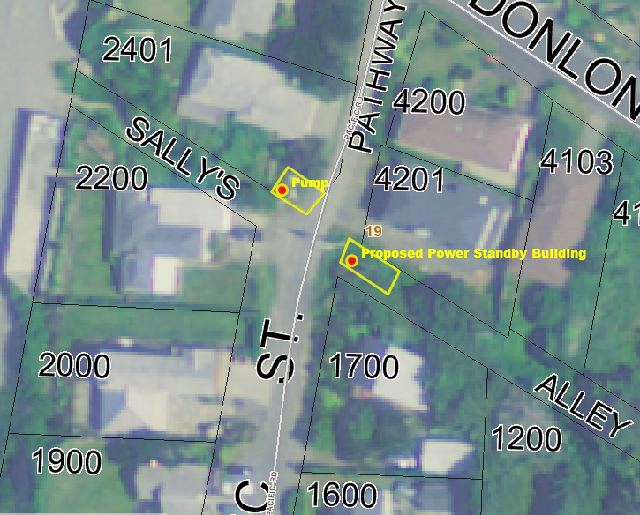The following criteria from the Clatsop County Land and Water Development and Use Ordinance (LWDUO) apply to the request:

§ 1.010-1.050 (Definitions), 2.020 (Type II Procedure), 2.025 (Type IIa Procedure), 2.110 (Mailed Notice of a Public Hearing), 2.120 (Procedure for Mailed Notice), 2.230-2.260 (Request for Review / Appeal et al), 3.060 (Arch Cape Rural Community Residential Zone), 4.100 (Site Development Review Overlay District [SDRO]), 4.116 (Arch Cape Variance), 4.040 (Geologic Hazards Overlay), 4.080 (Shorelands Overlay District), and Clatsop County’s Standards Document Chapters 1-4.

In addition, the following elements of the Clatsop County Comprehensive Plan apply to the request: Goal 1 (Citizen Involvement); Goal 2 (Land Use Planning); Goal 5 (**Natural Resources, Scenic and Historic Areas, and Open Spaces**); Goal 6 (**Air, Water and Land Resources Quality**); Goal 7 (Natural Hazards); Goal 11 (Public Facilities and Services); and the Southwest Coastal Community Plan.

These documents are available for review at the Clatsop County Community Development Department office, 800 Exchange Street, Suite 100, Astoria, Oregon, and on-line at the county’s website, [www.co.clatsop.or.us](http://www.co.clatsop.or.us).

A copy of the application, all documents and evidence submitted by or on behalf of the applicant and applicable criteria are available for inspection at the Community Development Department Office during normal business hours (M-F, 8-5) at no cost and will be provided at reasonable cost.

If you have questions about this land use matter or need more information, please contact Julia Decker, Clatsop County Planner, at (503) 325-8611 or via email at [jdecker@co.clatsop.or.us](mailto:jdecker@co.clatsop.or.us).

**Notice to Mortgagee, Lien Holder, Vendor or Seller:** ORS Chapter 215 requires that if you receive this notice it must promptly be forwarded to the purchaser.

**Date Mailed: August 1, 2013**