**Clatsop County**

**Community Development**

**800 Exchange Street, Suite 100,**

**Astoria, OR 97103**

**ph: 503-325-8611**



**fx: 503-338-3606**

**em: comdev@co.clatsop.or.us** [**www.co.clatsop.or.us**](http://www.co.clatsop.or.us)



**PUBLIC NOTICE FOR AN APPLICATION BEFORE THE**

**COMMUNITY DEVELOPMENT DIRECTOR**

In the matter of a Minor Design Review application submitted by William Starnes, on behalf of the Castle Rock Estates Home Owners Association, for after-the-fact approval to remove five trees on a lot owned by Castle Rock Estates Home Owners Association, located between Buena Vista Drive and Big Cedar Drive, in Arch Cape, Oregon. The legal description of the parcel is T4N, R10W, Sec. 19CA, TL 8500. Please see Page 2 of this notice for a vicinity map.

APRX. DATE OF DECISION: September 17, 2013

COMMENT PERIOD: August 26, 2013, to September 16, 2013

SEND COMMENTS TO: Clatsop County Community Development, 800 Exchange Street, Suite 100, Astoria, Oregon 97103

CONTACT PERSON: Julia Decker, Clatsop County Planner

You are receiving this notice because you either own property within 250 feet of the property that serves as the subject of the land use application described in this letter or you are considered to be an affected state or federal agency, local government, or special district. A vicinity map for the subject property may be found on page 2.

NOTICE IS HEREBY GIVEN that Clatsop County’s Community Development Department has received the land use application described in this letter. Pursuant to section 4.100 of the Clatsop County Land Water Development and Use Ordinance, a **public meeting is not necessary** as the review is minor and does not result in an expansion of the exterior dimensions and/or footprint of a structure and is not associated with any new residential development proposing to construct a dwelling; development and construction of public or private roads; change in use, variance request, conditional use permit; or other use requiring review through Type II, III, or IV procedures. Pursuant to Section 2.020 of the Clatsop County Land and Water Development and Use Ordinance (LWDUO), the Department Director is tentatively scheduled to render a decision based on evidence and testimony on Tuesday, September 17, 2013, at the Community Development Department, Public Service Building 800, 800 Exchange St., Suite 100, Astoria, OR 97103.

All interested persons are invited to submit testimony and evidence in writing by addressing a letter to the Clatsop County Community Development Director, 800 Exchange Street, Suite 100, Astoria, OR 97103. Written comments may also be sent via FAX to 503-338-3606 or via email to [jdecker@co.clatsop.or.us](mailto:jdecker@co.clatsop.or.us). Written comments must be received in this office no later than **5 pm on Monday, September 16, 2013,** in order to be considered by the Directorand in thedecision.

NOTE: Failure to raise an issue in a hearing, in person or by letter or email, or failure to provide statements or evidence sufficient to afford the decision maker an opportunity to respond to the issue precludes an appeal based on that issue.

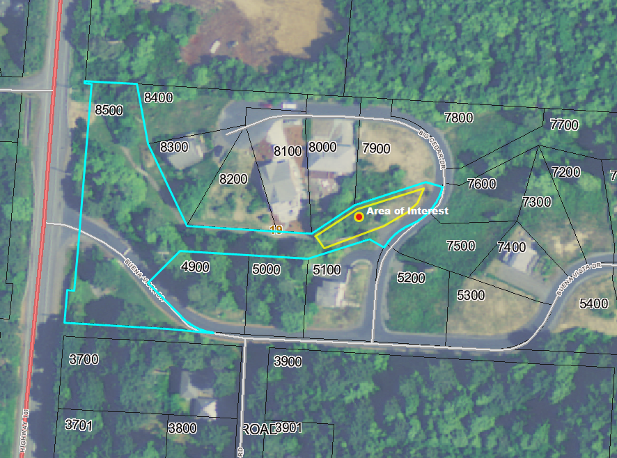The following criteria from **2009 Aerial**

the Clatsop County Land

and Water Development and Use Ordinance (LWDUO) apply to the request:

§ 1.010-1.050 (Definitions), 2.020 (Type II Procedure), 2.115 (Mailed Notice of a Type II Procedure), 2.120 (Procedure for Mailed Notice), 2.230-2.260 (Request for Review / Appeal et al), 3.060 (Arch Cape Rural Community Residential Zone), 4.100 (Rural Community Overlay District [/RCO]), and Clatsop County’s Standards Document Chapters 1-4.

In addition, the following elements of the Clatsop County Comprehensive Plan apply to the request: Goal 1 (Citizen Involvement); Goal 2 (Land Use Planning); Goal 5 (**Natural Resources, Scenic and Historic Areas, and Open Spaces**); Goal 6 (**Air, Water and Land Resources Quality**); Goal 8 (Recreational Needs); Goal 9 (Economy); Goal 10 (Housing); Goal 11 (Public Facilities and Services); Goal 12 (Transportation); and the Southwest Coastal Community Plan.

These documents are available for review at the Clatsop County Community Development Department office, 800 Exchange Street, Suite 100, Astoria, Oregon, and online at the county’s website, [www.co.clatsop.or.us](http://www.co.clatsop.or.us).

A copy of the application, all documents and evidence submitted by or on behalf of the applicant and applicable criteria are available for inspection at the Community Development Department Office during normal business hours (M-F, 8-5) at no cost and will be provided at reasonable cost.

If you have questions about this land use matter or need more information, please contact Julia Decker, Clatsop County Planner, at (503) 325-8611, or via email at [jdecker@co.clatsop.or.us](mailto:jdecker@co.clatsop.or.us).

**Notice to Mortgagee, Lien Holder, Vendor or Seller:** ORS Chapter 215 requires that if you receive this notice it must promptly be forwarded to the purchaser.

**Date Mailed: August 26, 2013**