**Clatsop County**

**Transportation & Development Services**

**800 Exchange Street, Suite 100,**

**Astoria, OR 97103**

**ph: 503-325-8611**



**fx: 503-338-3666**

**em: comdev@co.clatsop.or.us** [**www.co.clatsop.or.us**](http://www.co.clatsop.or.us)



**PUBLIC NOTICE FOR AN ISSUE BEFORE THE**

**COMMUNITY DEVELOPMENT DIRECTOR**

In the matter of a Major Design Review application submitted by Caitlyn Horsley, Solar City Corporation, for a roof-mounted photovoltaic (solar) collection system on behalf of Tunquelen LLC, on property owned by Tunquelen LLC, located at 80172 Pacific Road, in Arch Cape, Oregon. The legal description of the parcel is T4N, R10W, Sec. 19CC, TL 02900.

(*For a map see Page 2 of this notice*)

APRX. DATE OF DECISION: October 19, 2012

COMMENT PERIOD: September 28, 2012, to October 17, 2012

**DESIGN REVIEW HEARING: October 17, 2012, 6 pm Arch Cape Fire Hall, 79816 E. Beach Road**

SEND COMMENTS TO: Public Service Building 800, 800 Exchange Street, Suite 100, Astoria, Oregon 97103

CONTACT PERSON: Julia Decker, Clatsop County Planner

You are receiving this notice because you either own property within 250 feet of the property that serves as the subject of the land use application described in this letter or you are considered to be an affected state or federal agency, local government, or special district. A vicinity map for the subject property may be found on page 2.

NOTICE IS HEREBY GIVEN that Clatsop County’s Community Development Department has received the land use application described in this letter. Pursuant to section 4.100 of the Clatsop County Land Water Development and Use Ordinance, a **Public Hearing is scheduled before the Design Review Committee on Wednesday, October 17, 2012.** Pursuant to Section 2.020 of the Clatsop County Land and Water Development and Use Ordinance (LWDUO), the Department Director is tentatively scheduled to render a decision based on evidence and testimony on Friday, October 19, 2012, at the Public Service Building, 800 Exchange St., Suite 100, Astoria, OR 97103.

All interested persons are invited to submit testimony and evidence in writing by addressing a letter to the Clatsop County Community Development Director, 800 Exchange Street, Suite 100, Astoria, OR 97103. Written comments may also be sent via FAX to 503-338-3606 or via email to [jdecker@co.clatsop.or.us](mailto:jdecker@co.clatsop.or.us). Written comments must be received in this office no later than **5 pm on Thursday, October 18, 2012,** in order to be considered by the Directorand in thedecision.

NOTE: Failure of an issue to be raised in a hearing, in person or by letter, or failure to provide statements or evidence sufficient to afford the decision maker an opportunity to respond to the issue precludes an appeal based on that issue.

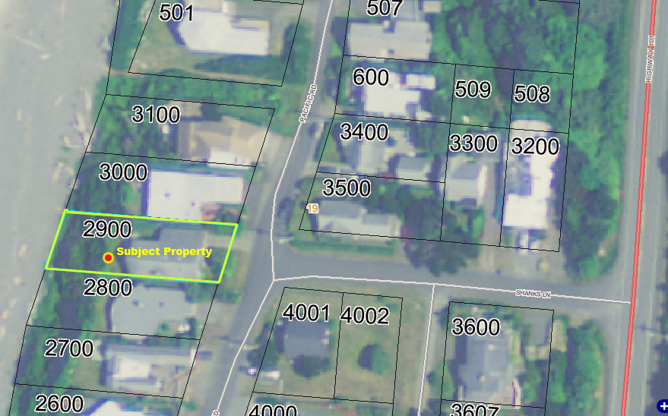The following criteria from the Clatsop County Land and Water Development and Use Ordinance (LWDUO) apply to the request:

§ 1.010-1.050 (Definitions), 2.020 (Type II Procedure), 2.110 (Mailed Notice of a Public Hearing), 2.120 (Procedure for Mailed Notice), 2.230-2.260 (Request for Review / Appeal et al), 3.060 (Arch Cape Rural Community Residential Zone), 4.100 (Site Development Review Overlay District [SDRO]), and Clatsop County’s Standards Document Chapters 1-4.

In addition, the following elements of the Clatsop County Comprehensive Plan apply to the request: Goal 1 (Citizen Involvement); Goal 2 (Land Use Planning); Goal 5 (**Natural Resources, Scenic and Historic Areas, and Open Spaces**); Goal 6 (**Air, Water and Land Resources Quality**); Goal 7 (Natural Hazards); Goal 8 (Recreational Needs); Goal 9 (Economy); Goal 10 (Housing); Goal 11 (Public Facilities and Services); Goal 12 (Transportation); Goal 13 (Energy Conservation); and the Southwest Coastal Community Plan.

These documents are available for review at the Clatsop County Community Development Department office, 800 Exchange Street, Suite 100, Astoria, Oregon, and on-line at the county’s website, [www.co.clatsop.or.us](http://www.co.clatsop.or.us).

A copy of the application, all documents and evidence submitted by or on behalf of the applicant and applicable criteria are available for inspection at the Community Development Department Office during normal business hours (M-F, 8-5) at no cost and will be provided at reasonable cost.

If you have questions about this land use matter or need more information, please contact Julia Decker, Clatsop County Planner, at (503) 325-8611 or via email at [jdecker@co.clatsop.or.us](mailto:jdecker@co.clatsop.or.us).

**Notice to Mortgagee, Lien Holder, Vendor or Seller:** ORS Chapter 215 requires that if you receive this notice it must promptly be forwarded to the purchaser.

**Date Mailed: September 27, 2012**